Computer Networks Lab CS302

Lab – 6 Report

**Ragul N S – 191CS146 Rakshith H R – 191CS148**

Questions:

## Part A 1. Print the list of network interfaces, their MAC addresses and their assigned IP addresses, if any.

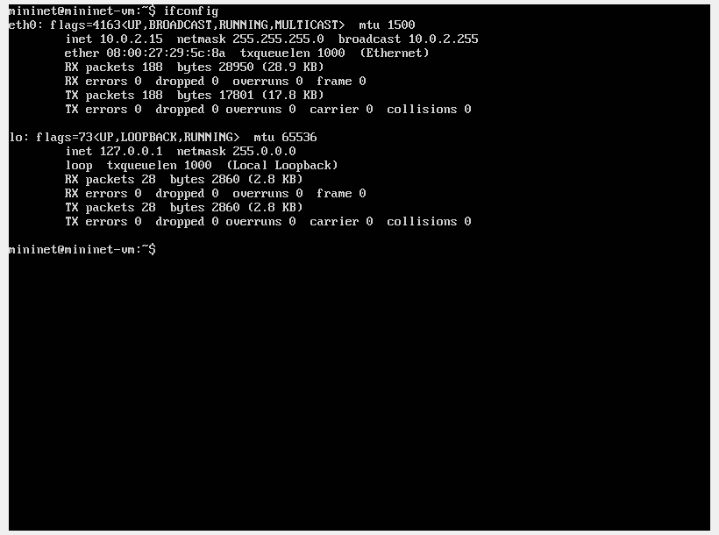

The machine has one network interface (lo is the localhost interface) which is eth0.

The IP Address – 10.0.2.15

MAC Address – 08:00:27:29:5c:8a

## 2. Calculate the latency between mininet vm and www.rutgers.edu for 10 packets. Repeat the result for stanford.edu and www.google.co.in and compare the difference in latency.

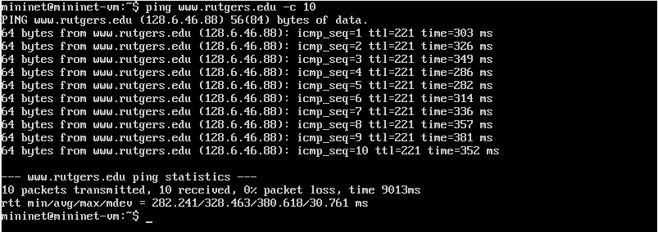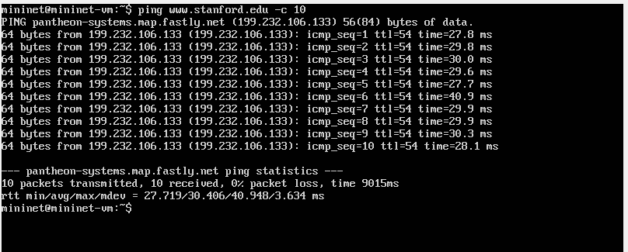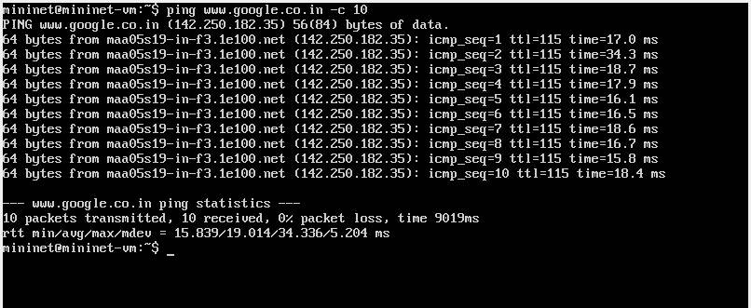

The Avg latency for rutgers.edu is 328.463 ms, stanford.edu is 30.406 ms and for google.co.in is 19.014 ms.

The difference between rutgers.edu and stanford.edu is 298.057 ms, stanford.edu and google.co.in is 11.392 ms, rutgers.edu and google.co.in is 309.449 ms.

Part B Create a simple two node network using "sudo mn" and do the following a. Print the MAC address of host h1. Print the MAC addresses of switch s1. Explain the different interfaces that s1 has.

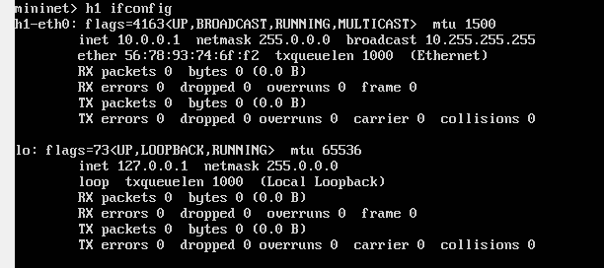

The mac address of h1-eth0 is 56:78:93:74:6f:f2

The Ip address of h1 eth0 is 10.0.0.1.

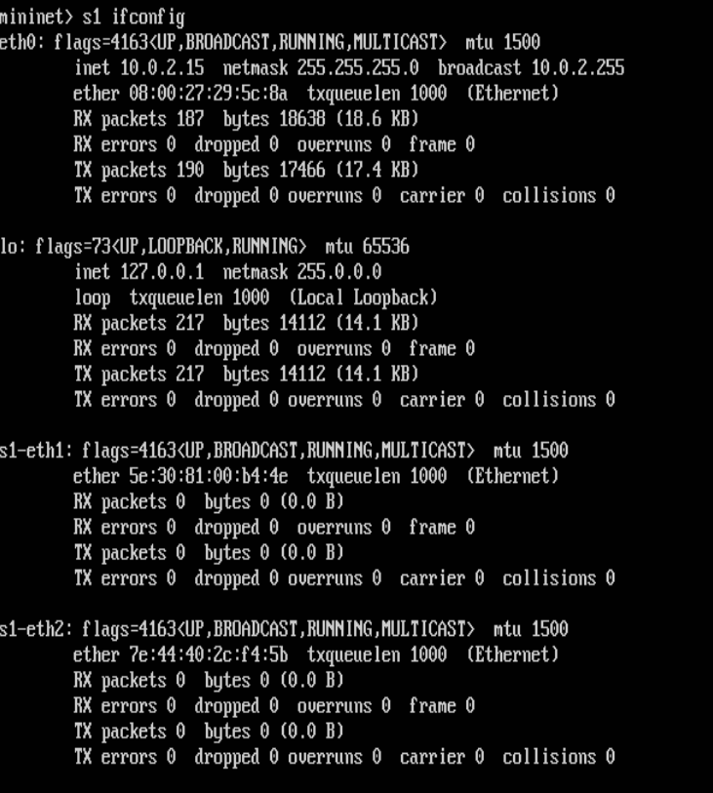

The mac address of the switch s1 is 08:00:27:29:5c:8a

There are two extra interfaces now such as s1-eth0 and s2-eth0. The s1-eth0 is the interface between the switch and the host h1 and the s1-eth1 is the interface between the switch and the host h2. They have the details regarding those interfaces.

## b. Ping h1 from h2 and view the ARP entries stored at hosts h1 and h2. 3. Measure the TCP throughput from h1 to h2 using iperf

The below image shows the ping operation from the node h1 to h2. Ping operation sends packets from h1 to h2.

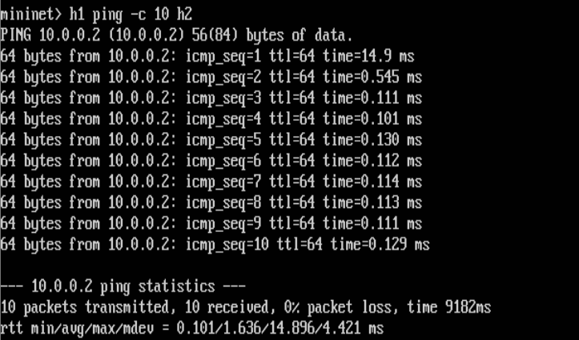

After we ping h2 from h1 we use the command arp -a to see the arp table of both the nodes.

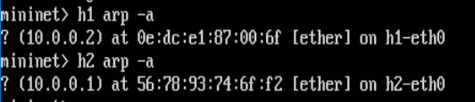

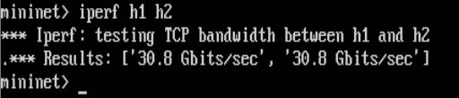

By running the command iperf h1 h2 we can find the throughput of the tcp connection. From this image we can the see that the value here is is 30.8 Gbit/sec.